T.A. Marryshow Community College.
Computer and Electronics Department


Project Report

Student Name | Kemayah Noel
Student ID No. | AL2024015941
Course and No. | Web Design CIT232
Lecturer | Mr. Christopher Mignon
Project Title | Flavorful Website
Date | 12/05/2025
Hosted URL | noels.rf.gd
GitHub Repository URL | Flavorful Website Link

Contents
1. Introduction 1
1.1. Background 1
1.2. Problem 1
1.3. Objective and Scope 1
2. Technology Stack & Requirement Analysis 1
2.1. Technology Stack 1
2.2. Feature List 1
2.3. Feasibility study 1
2.4. Budget estimate 1
3. Design 1
3.1. Project plan & Timeline 1
3.2. High level designs 2
4. Implementation 2
5. Database Design & CMS Structure 2
6. Testing and Deployment 2
7. Project Reflection & Conclusion 2
8. References 3
9. Appendix 3

Introduction
The Flavorful Website is a web-based ordering and delivery platform developed as a test site for the Flavourful company, which produces and distributes Penacool products throughout Grenada. The system allows customers to register, login, place orders, and track balances while enabling the business to manage orders more efficiently.

Background
Flavourful currently operates as just a face-to-face distributor without an online ordering system or website. This project was created to demonstrate how the company could expand digitally. The website also served as a learning exercise to apply web development concepts such as hosting, database integration, and full-stack development.

Problem
The company frequently visits customers who may not be ready to purchase, resulting in wasted fuel, time, and resources. Customers also lack a convenient way to pre-order products. An online ordering platform helps solve these issues by allowing advance orders and better delivery planning.

Objective and Scope
The primary objective was to design and implement a responsive web application consisting of 13 functional pages: Home, About, Prices, Team, Socials, Contact, Buy Now, Order, Delivery, Balance, Calculator, Login and Register. The website supports user authentication, online ordering, balance tracking and delivering requests.

Technology Stack & Requirement Analysis
You need to use a hosting site to make your website available online., GitHub for version control to save your files and the files that show the information that shows on the website. A database is needed to hold the user’s information, balance, and what they want delivered. To hold the products, updated users account balance and order items. PHP is needed to hide the connection to the database and to hold the database.

Technology Stack
Front-End Technologies:
- HTML
- CSS
- JavaScript
Back-End Technologies:
- PHP
- MySQL

Tools and Platforms:
- InfinityFree (Hosting)
- GitHub (Version Control)
- Visual Studio Code (Code Writing & Debugging)
- phpMyAdmin (Import Database)

2.2. Feature List
- User registration and secure login system
- Role-based authentication
- Product browsing and ordering
- Delivery option selection
- Account balance management
- Transaction history tracking
- Built-in calculator
- External calculator
- Contact and support form
- Fully responsive design

2.3 Feasibility Study
The project was technically and economically feasible. All system requirements were met using freely available tools and platforms. The project also provided practical experience with CRUD operations, authentication, and database management.

2.4 Budget Estimate
The estimated budget for the project was USD $12. However, no financial cost was incurred since GitHub and InfinityFree were used as free development and hosting platforms.

3.1 Project Plan and Timeline
The estimated project duration was three (3) weeks.
• Planning – 2 days
• Design – 3 days
• Development – 5 days
• Testing – 6 days
• Deployment – 2 days

3.2. High level designs
- Sitemap: A diagram showing the structure of the 13 pages.
- Wireframes/Low-Fidelity Mockups: Sketches of key page layouts.
- User Interaction Diagrams (Optional): Use Case or Activity Diagram for key features (e.g., login process, form submission).

4. Implementation
The project follows a modular file structure for maintainability and scalability:

/phpMyAdmin
Schema.sql

/htdocs
index.php
about.php
prices.php
workers.php
socials.php
contact.php
buy-now.php
order.php
delivery.php
calculator.php
register.php
login.php
balance.php
utils.php

Reusable PHP components were used to maintain consistent navigation. CSS media queries and Flexbox were implemented to ensure responsiveness across different devices. JavaScript was used for form validation, dynamic cart updates, and modal interactions.

5. Database Design and CMS Structure

The database consists of the following core tables:
• users
• products
• orders
• order_items
• transactions
PDO prepared statements were used to ensure database security. Passwords are hashed, and authentication checks prevent unauthorized access.

Testing and Deployment
- Testing Summary: System testing was performed by creating a user account and simulating real orders. Responsiveness was tested using browser developer tools. The website was deployed using InfinityFree and successfully accessed via its public domain.
- Deployment Process: Explain the steps taken to host the website. Provide the live URL at the top of the document.

Project Reflection & Conclusion
- Reflection: This project significantly improved my understanding of full-stack web development. Key learning areas included secure authentication, database integration, form handling, deployment, and real-world problem solving.

- Conclusion: The Flavorful Website meets all project objectives by providing a secure and functional online ordering platform. It benefits both customers and the business by improving efficiency, accessibility, and order accuracy.

References
There are no sources in the current document.
InfinityFree, GitHub, Laptop and Visual Studio Code used.

Appendix
- Screenshots of the final, hosted website.

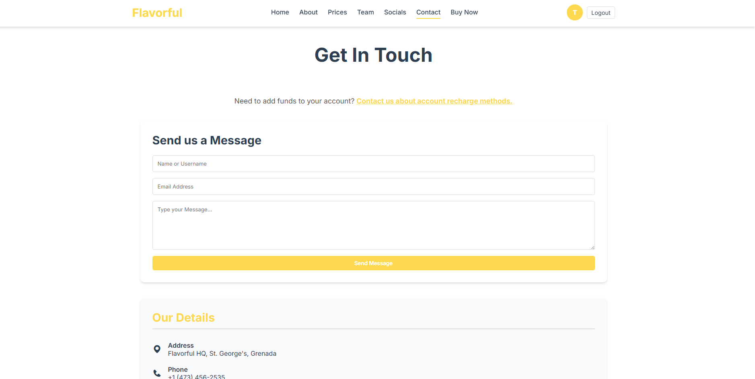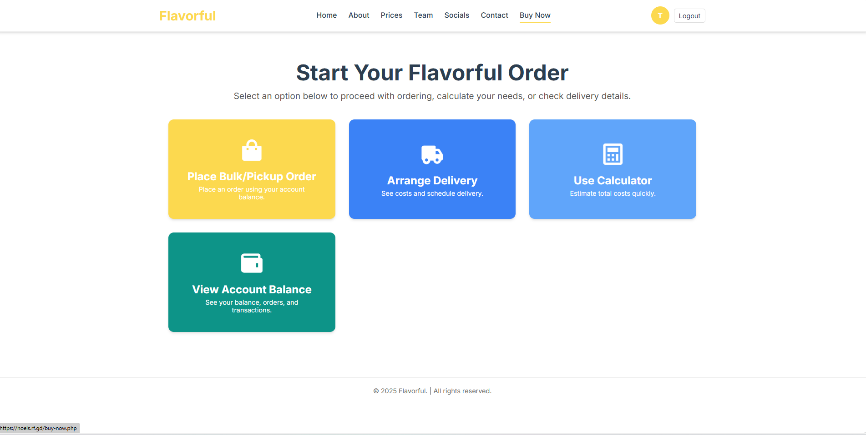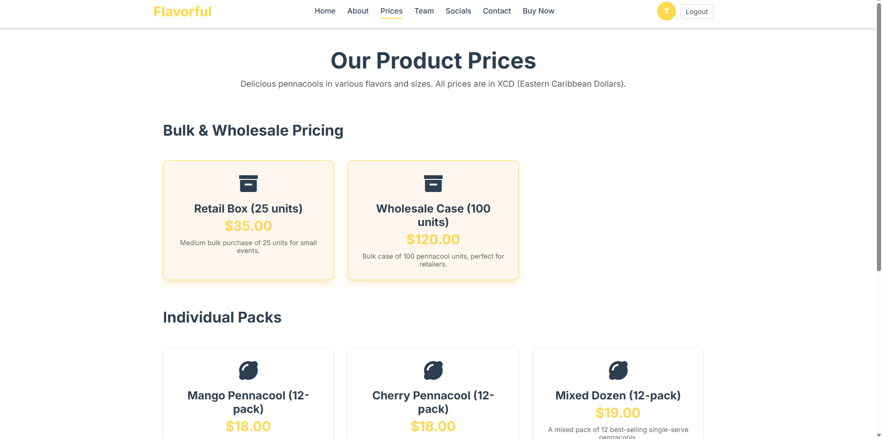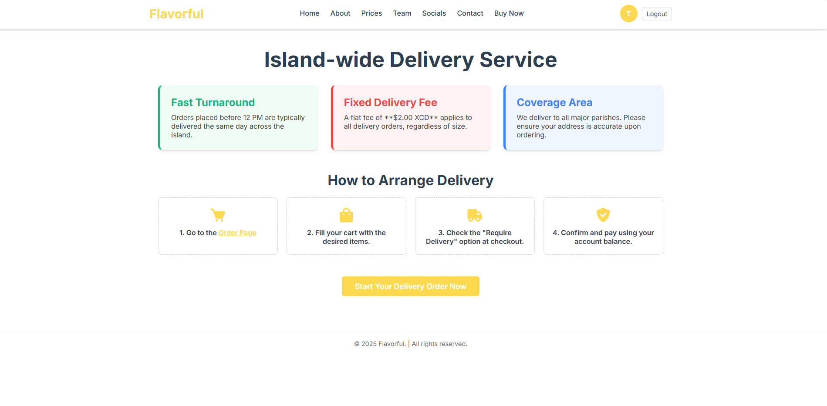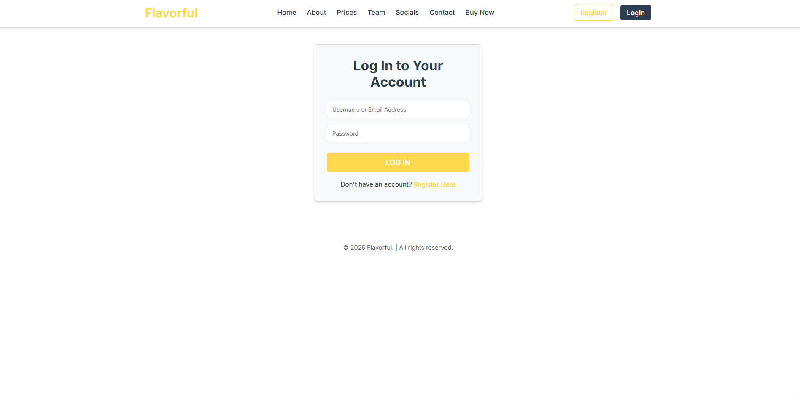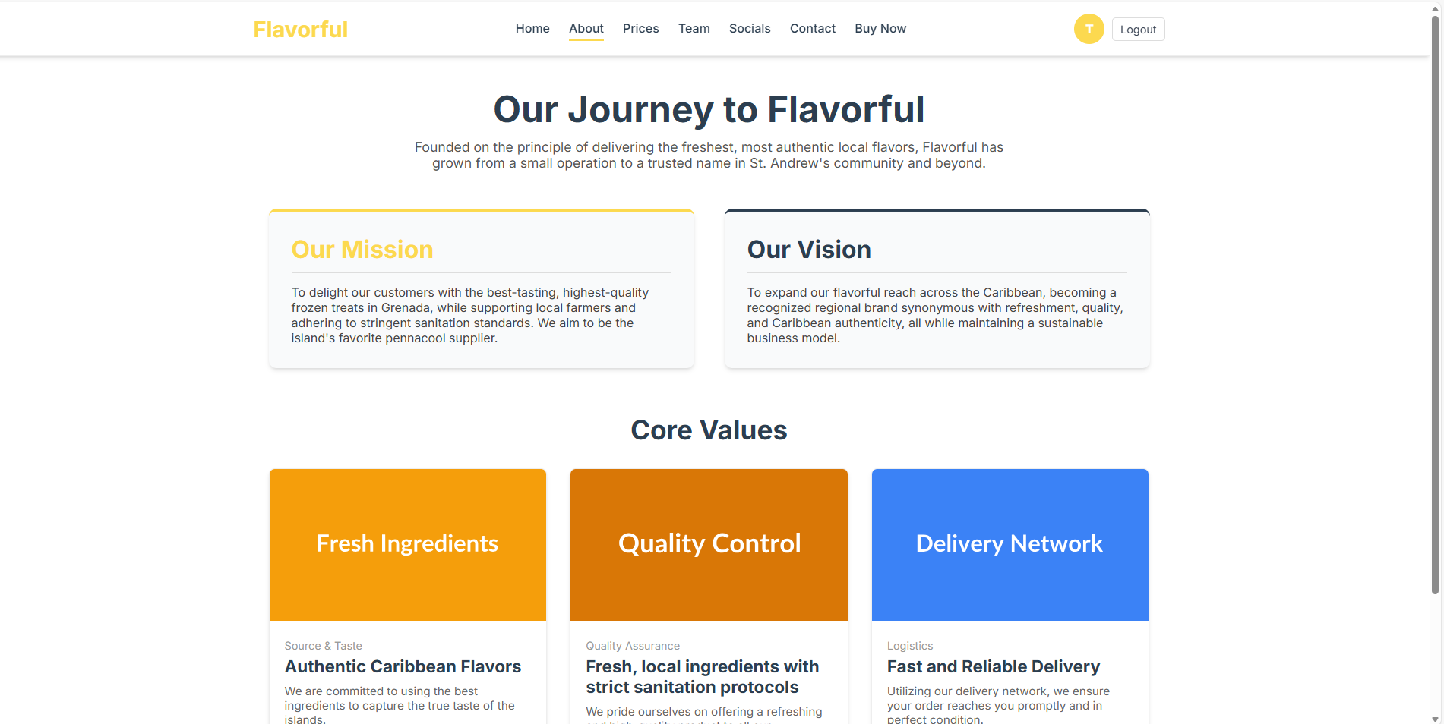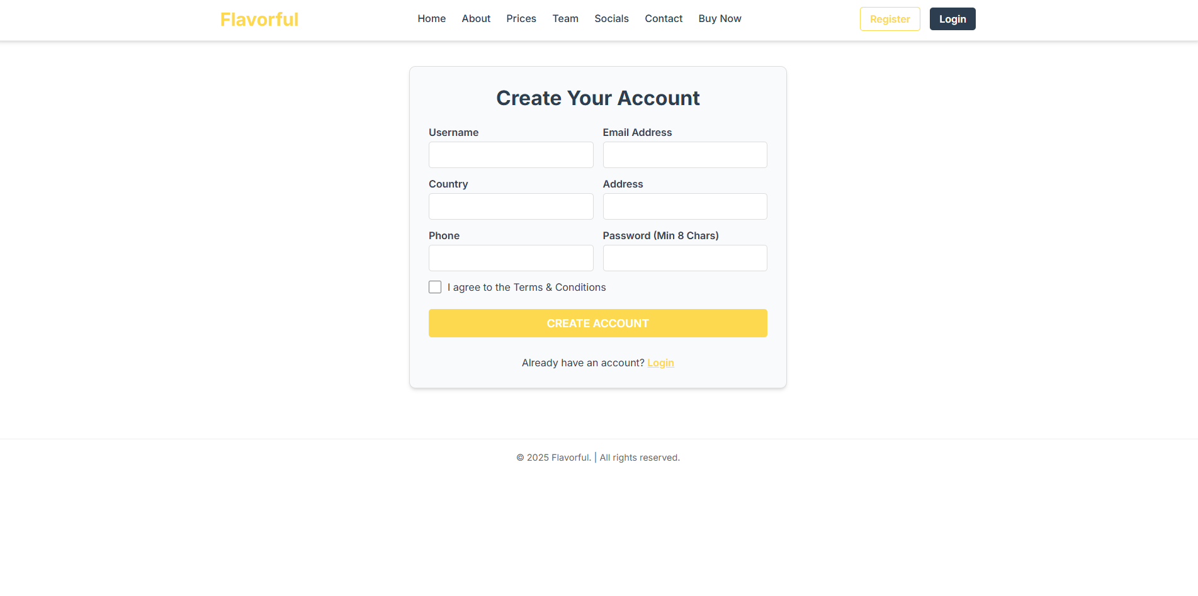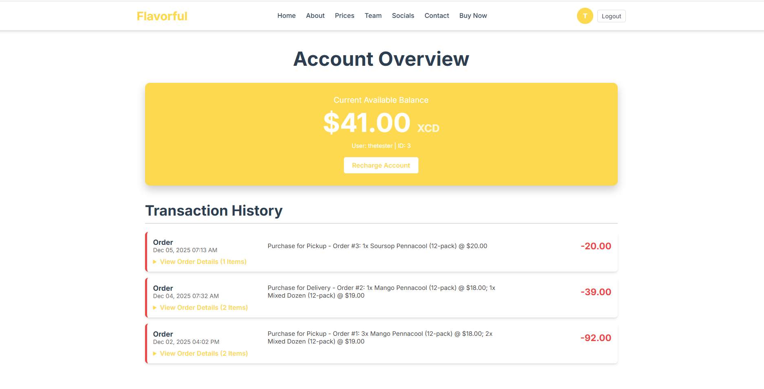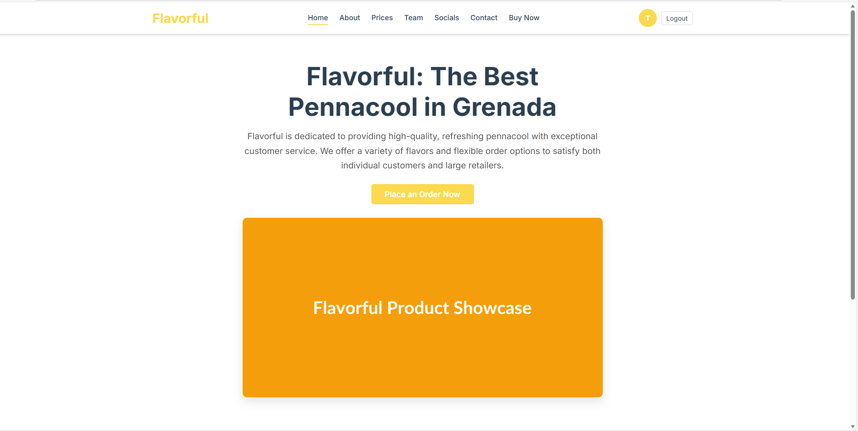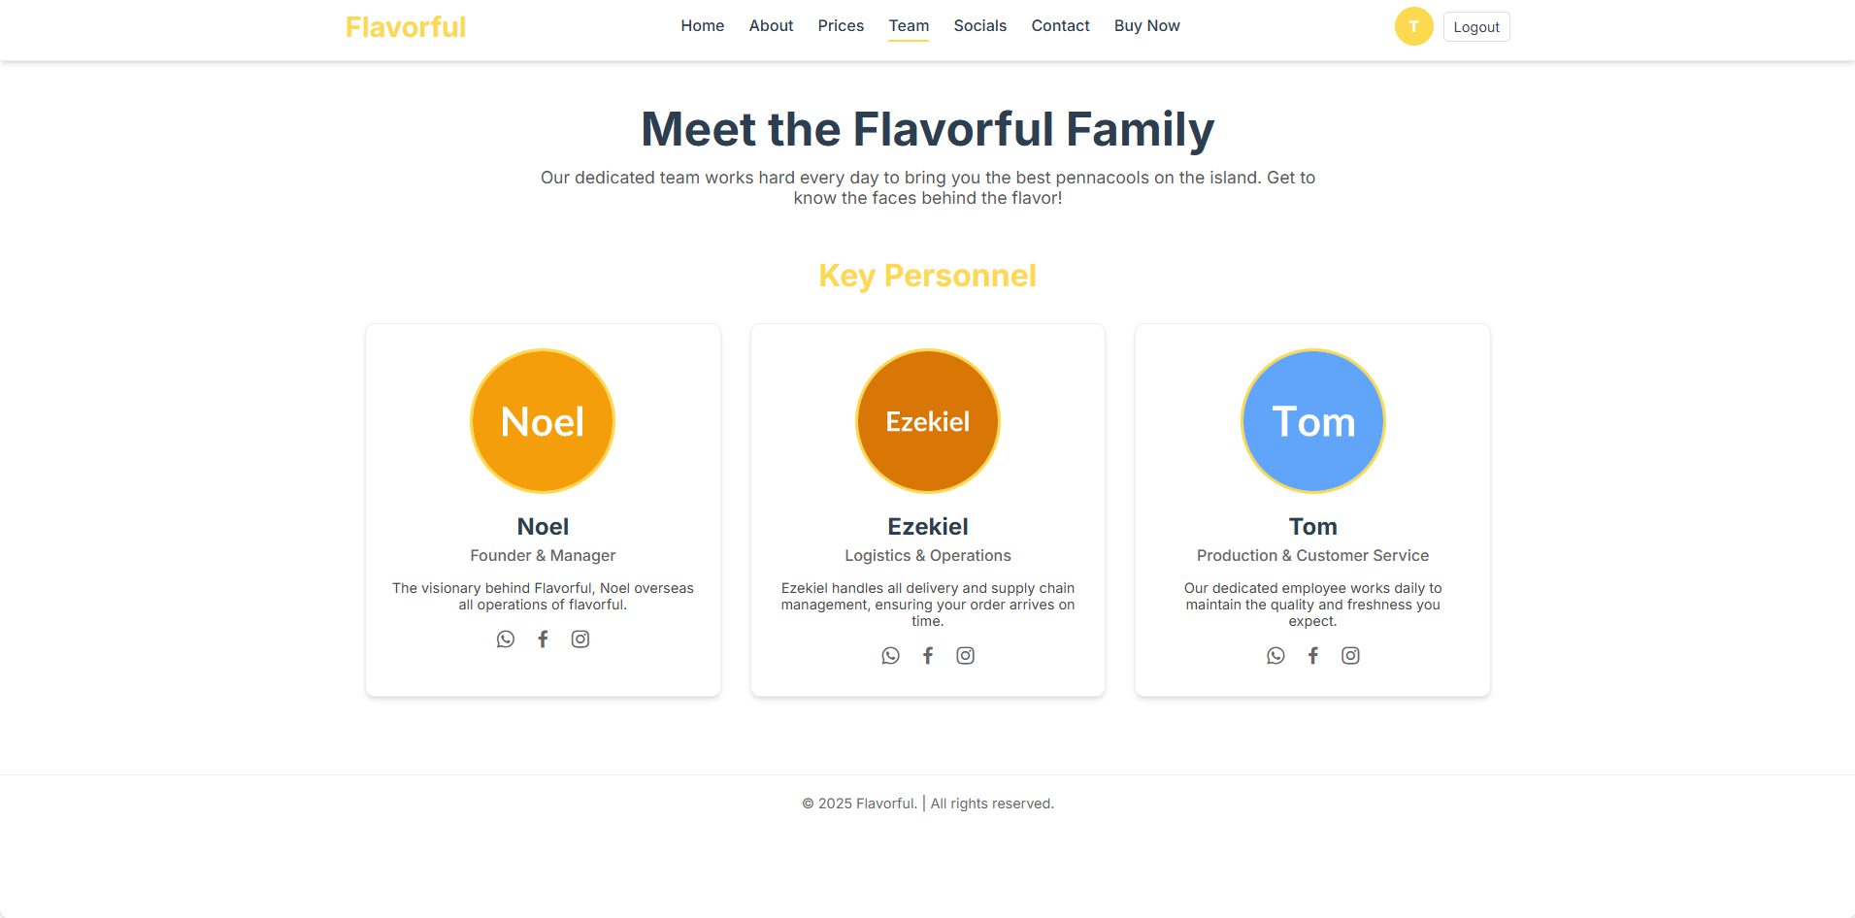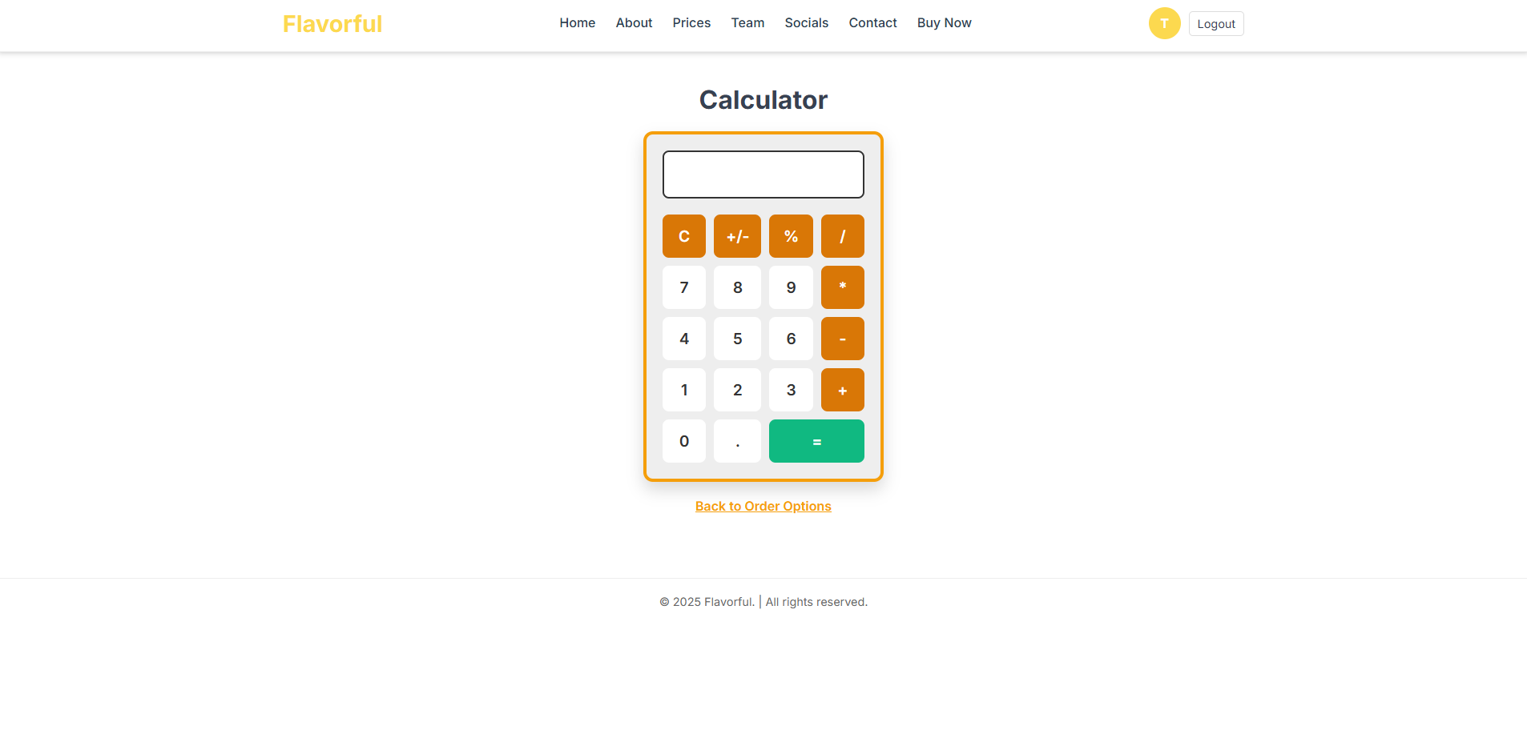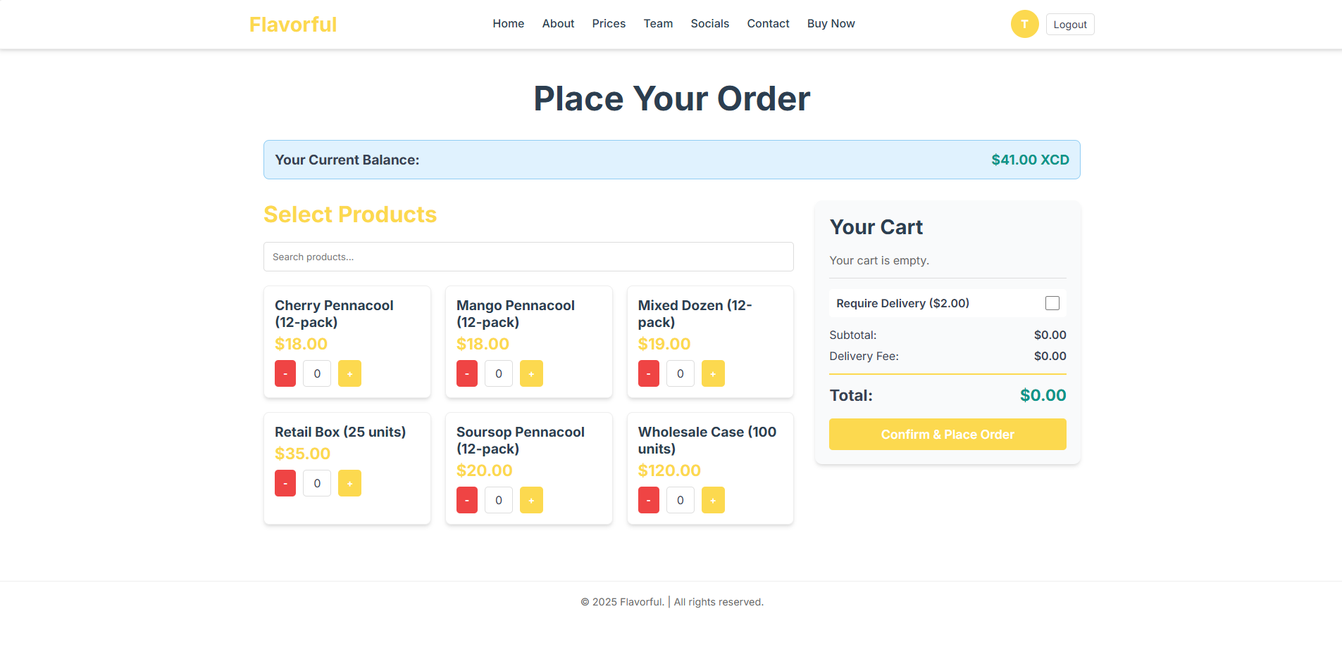

Exported sql code

-- phpMyAdmin SQL Dump
-- version 4.9.0.1
-- https://www.phpmyadmin.net/
--
-- Host: sql300.infinityfree.com
-- Generation Time: Dec 05, 2025 at 12:19 PM
-- Server version: 11.4.7-MariaDB
-- PHP Version: 7.2.22

SET SQL_MODE = "NO_AUTO_VALUE_ON_ZERO";
SET AUTOCOMMIT = 0;
START TRANSACTION;
SET time_zone = "+00:00";

/*!40101 SET @OLD_CHARACTER_SET_CLIENT=@@CHARACTER_SET_CLIENT */;
/*!40101 SET @OLD_CHARACTER_SET_RESULTS=@@CHARACTER_SET_RESULTS */;
/*!40101 SET @OLD_COLLATION_CONNECTION=@@COLLATION_CONNECTION */;
/*!40101 SET NAMES utf8mb4 */;

--
-- Database: `if0_40502206_flavorful`
--

-- --------------------------------------------------------

--
-- Table structure for table `orders`
--

CREATE TABLE `orders` (
`order_id` int(11) NOT NULL,
`user_id` int(11) NOT NULL,
`order_date` timestamp NULL DEFAULT current_timestamp(),
`total_amount` decimal(10,2) NOT NULL,
`status` enum('Pending','Processing','Completed','Cancelled') DEFAULT 'Pending',
`delivery_required` tinyint(1) DEFAULT 0
) ENGINE=MyISAM DEFAULT CHARSET=latin1 COLLATE=latin1_swedish_ci;

--
-- Dumping data for table `orders`
--

INSERT INTO `orders` (`order_id`, `user_id`, `order_date`, `total_amount`, `status`, `delivery_required`) VALUES
(1, 3, '2025-12-03 00:02:12', '92.00', 'Pending', 0),
(2, 3, '2025-12-04 15:32:25', '39.00', 'Pending', 1),
(3, 3, '2025-12-05 15:13:34', '20.00', 'Pending', 0);

-- --------------------------------------------------------

--
-- Table structure for table `order_items`
--

CREATE TABLE `order_items` (
`order_item_id` int(11) NOT NULL,
`order_id` int(11) NOT NULL,
`product_id` int(11) NOT NULL,
`quantity` int(11) NOT NULL,
`price_at_order` decimal(10,2) NOT NULL
) ENGINE=MyISAM DEFAULT CHARSET=latin1 COLLATE=latin1_swedish_ci;

--
-- Dumping data for table `order_items`
--

INSERT INTO `order_items` (`order_item_id`, `order_id`, `product_id`, `quantity`, `price_at_order`) VALUES
(1, 1, 1, 3, '18.00'),
(2, 1, 4, 2, '19.00'),
(3, 2, 1, 1, '18.00'),
(4, 2, 4, 1, '19.00'),
(5, 3, 3, 1, '20.00');

-- --------------------------------------------------------

--
-- Table structure for table `products`
--

CREATE TABLE `products` (
`product_id` int(11) NOT NULL,
`name` varchar(100) NOT NULL,
`price` decimal(10,2) NOT NULL,
`description` text DEFAULT NULL,
`type` enum('single','bulk') NOT NULL
) ENGINE=MyISAM DEFAULT CHARSET=latin1 COLLATE=latin1_swedish_ci;

--
-- Dumping data for table `products`
--

INSERT INTO `products` (`product_id`, `name`, `price`, `description`, `type`) VALUES
(1, 'Mango Pennacool (12-pack)', '18.00', 'A convenient pack of 12 single-serve Mango pennacools.', 'single'),
(2, 'Cherry Pennacool (12-pack)', '18.00', 'A convenient pack of 12 single-serve Cherry pennacools.', 'single'),
(3, 'Soursop Pennacool (12-pack)', '20.00', 'A convenient pack of 12 single-serve Soursop pennacools (Premium Flavor).', 'single'),
(4, 'Mixed Dozen (12-pack)', '19.00', 'A mixed pack of 12 best-selling single-serve pennacools.', 'single'),
(5, 'Wholesale Case (100 units)', '120.00', 'Bulk case of 100 pennacool units, perfect for retailers.', 'bulk'),
(6, 'Retail Box (25 units)', '35.00', 'Medium bulk purchase of 25 units for small events.', 'bulk');

-- --------------------------------------------------------

--
-- Table structure for table `transactions`
--

CREATE TABLE `transactions` (
`transaction_id` int(11) NOT NULL,
`user_id` int(11) NOT NULL,
`order_id` int(11) DEFAULT NULL,
`transaction_type` enum('Order','Recharge','Refund') NOT NULL,
`amount` decimal(10,2) NOT NULL,
`description` text DEFAULT NULL,
`transaction_date` timestamp NULL DEFAULT current_timestamp()
) ENGINE=MyISAM DEFAULT CHARSET=latin1 COLLATE=latin1_swedish_ci;

--
-- Dumping data for table `transactions`
--

INSERT INTO `transactions` (`transaction_id`, `user_id`, `order_id`, `transaction_type`, `amount`, `description`, `transaction_date`) VALUES
(1, 3, 1, 'Order', '-92.00', 'Purchase for Pickup - Order #1: 3x Mango Pennacool (12-pack) @ $18.00; 2x Mixed Dozen (12-pack) @ $19.00', '2025-12-03 00:02:12'),
(2, 3, 2, 'Order', '-39.00', 'Purchase for Delivery - Order #2: 1x Mango Pennacool (12-pack) @ $18.00; 1x Mixed Dozen (12-pack) @ $19.00', '2025-12-04 15:32:25'),
(3, 3, 3, 'Order', '-20.00', 'Purchase for Pickup - Order #3: 1x Soursop Pennacool (12-pack) @ $20.00', '2025-12-05 15:13:34');

-- --------------------------------------------------------

--
-- Table structure for table `users`
--

CREATE TABLE `users` (
`user_id` int(11) NOT NULL,
`username` varchar(50) NOT NULL,
`email` varchar(100) NOT NULL,
`password_hash` varchar(255) NOT NULL,
`country` varchar(50) DEFAULT NULL,
`address` text DEFAULT NULL,
`phone` varchar(20) DEFAULT NULL,
`balance` decimal(10,2) DEFAULT 0.00,
`role` enum('user','admin') DEFAULT 'user',
`created_at` timestamp NULL DEFAULT current_timestamp()
) ENGINE=MyISAM DEFAULT CHARSET=latin1 COLLATE=latin1_swedish_ci;

--
-- Dumping data for table `users`
--

INSERT INTO `users` (`user_id`, `username`, `email`, `password_hash`, `country`, `address`, `phone`, `balance`, `role`, `created_at`) VALUES
(3, 'thetester', 'bo@gmail.com', '$2y$10$tbJYR2E.5bSKULPxNAnpzeZ4KwQ6H2/Z4VTG/opeQIQ5ou.G83vpW', 'Grenada', 'St. David', '473404-5559', '41.00', 'user', '2025-12-02 23:42:33');

--
-- Indexes for dumped tables
--

--
-- Indexes for table `orders`
--
ALTER TABLE `orders`
ADD PRIMARY KEY (`order_id`),
ADD KEY `user_id` (`user_id`);

--
-- Indexes for table `order_items`
--
ALTER TABLE `order_items`
ADD PRIMARY KEY (`order_item_id`),
ADD KEY `order_id` (`order_id`),
ADD KEY `product_id` (`product_id`);

--
-- Indexes for table `products`
--
ALTER TABLE `products`
ADD PRIMARY KEY (`product_id`);

--
-- Indexes for table `transactions`
--
ALTER TABLE `transactions`
ADD PRIMARY KEY (`transaction_id`),
ADD KEY `user_id` (`user_id`),
ADD KEY `order_id` (`order_id`);

--
-- Indexes for table `users`
--
ALTER TABLE `users`
ADD PRIMARY KEY (`user_id`),
ADD UNIQUE KEY `username` (`username`),
ADD UNIQUE KEY `email` (`email`);

--
-- AUTO_INCREMENT for dumped tables
--

--
-- AUTO_INCREMENT for table `orders`
--
ALTER TABLE `orders`
MODIFY `order_id` int(11) NOT NULL AUTO_INCREMENT, AUTO_INCREMENT=4;

--
-- AUTO_INCREMENT for table `order_items`
--
ALTER TABLE `order_items`
MODIFY `order_item_id` int(11) NOT NULL AUTO_INCREMENT, AUTO_INCREMENT=6;

--
-- AUTO_INCREMENT for table `products`
--
ALTER TABLE `products`
MODIFY `product_id` int(11) NOT NULL AUTO_INCREMENT, AUTO_INCREMENT=7;

--
-- AUTO_INCREMENT for table `transactions`
--
ALTER TABLE `transactions`
MODIFY `transaction_id` int(11) NOT NULL AUTO_INCREMENT, AUTO_INCREMENT=4;

--
-- AUTO_INCREMENT for table `users`
--
ALTER TABLE `users`
MODIFY `user_id` int(11) NOT NULL AUTO_INCREMENT, AUTO_INCREMENT=4;
COMMIT;

/*!40101 SET CHARACTER_SET_CLIENT=@OLD_CHARACTER_SET_CLIENT */;
/*!40101 SET CHARACTER_SET_RESULTS=@OLD_CHARACTER_SET_RESULTS */;
/*!40101 SET COLLATION_CONNECTION=@OLD_COLLATION_CONNECTION */;

